

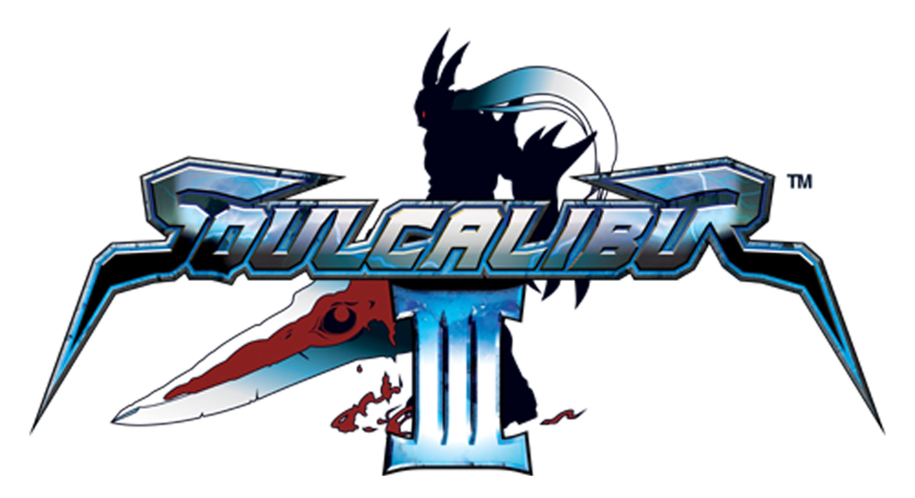

Takuji Kawano / Creating a character Q&A’s

- Name, position & length of time working on ‘creating characters’?
Takuji Kawano, Character Designer, Illustrator, 1 year

- Favourite Soulcalibur III character – who and why
Each character has its own appeal so I can’t decide.

- What is your exact role/ contribution in the development of a character?
I illustrate and design characters before we commence modelling.

- Where does the inspiration come from when beginning the process of character creation? - i.e. do you take inspiration from other people?
My inspiration comes from trying to live up to player expectations.

- Do you begin with an idea for a weapon and then build the character around it.
For the standard characters there is always a weapon before I start design but custom characters do not have a specific weapon so the rough costume design begins without a weapon.

- Do you design the costume as well as the character, or does someone else do the costume design?
I design both.

- What are the basic rules you have to follow when creating a new character – is there anything you are not allowed to do/ create?
I don’t think there is but I always try to design characters that will fit in the game as well as stand out.

- Are you responsible for one or more characters?
I am responsible for many characters.

- What is the strangest place you have taken inspiration from?
It’s not strange but paintings by Pieter Bruegel.

- When you create a character, do you make up a history/ story/ motivation for them?
I don’t make these, however, I try to demonstrate these aspects through the character’s appearance.

- Why do you think certain characters are more popular than other ones?
I believe that some characters are more popular because not all characters can
grab the players’ sympathy and admiration equally.

- Do you identify with any of the characters?
I feel close to Yun-seong as his star sign and blood type is the same as mine.

- What is your favourite special move?
Maxi’s Mark of the Snake.

- How do you get the movement of the characters so fluid?
I can’t answer this question as I don’t design the motion. The motion designer’s research and effort made this happened.

Character creation mode

- Everyone is talking about the new character creation mode in Soulcalibur III. Can you tell us whose idea it was to create this?
It was not one single person’s idea or creation but a collective effort. First there was a strong demand from fans for such a mode, then the producer and creators got together, discussed how they can realize this mode and it took off from there.

- You have begun to introduce ‘emotion’ into the characters – is this something you would like to develop further?
Yes, we do feel that this is something we would like to develop further.

- In character creation mode, you are allowing the gamer to ‘do your job’ – are you worried that people will not want to play your characters any more?
Not at all, I am happy and content as long as the players enjoy the game and more fans become devoted fans because of this new feature.

- Can you give us some hints/ tips about creating a character?
The key to creating a character is first visualising the whole image and being deliberate when selecting the appropriate parts.

- If you were judging a character creation competition, what qualities would you look for in the winner?
I don’t think I am qualified to be a judge however I would probably choose as the winner a character with an unorthodox combination of items which somehow presents a balanced look.

Visit our website:
www.soulcalibur-3.com

Notes to Editors

Developer: Namco Genre: Sword-fighting Action
No. of Players: 1-2 Platform: PlayStation®2
Peripherals: Analog Controller (DUALSHOCK®2), Memory Card (8MB) (for PlayStation®2)
Release Date: Quarter 4, 2005

About Sony Computer Entertainment Europe Ltd.
Sony Computer Entertainment Europe (SCEE), based in London, is responsible for the distribution, marketing and sales of PS one®, PlayStation®2 and PlayStation® Portable software and hardware in 104 territories across Europe, the Middle East, Africa and Oceania. SCEE also develops, publishes, markets and distributes games software for the three formats, and manages the third party licensing programs for these platforms in the PAL territories. At the end of June 2005, over 40 million PlayStation® units had been shipped across these PAL territories, over 102 million worldwide. Between its European debut on 24 November 2000 and 20th July 2005, over 33 million PlayStation®2 units have been shipped across the PAL territories, over 91 million world-wide, making it one of the most successful consumer electronic products in history. Between the launch of the PSP in Japan in December 2005 and 21 July 2005, over 5 million PSPs have been shipped worldwide.

PlayStation and the PlayStation logo, PS one and PS2 are registered trademarks of Sony Computer Entertainment Inc. PSP and UMD (Universal Media Disc) are trademarks of Sony Computer Entertainment Inc. All other trademarks are property of their respective owners.

More information about PlayStation products can be found at http://www.scee.com , www.yourpsp.com and www.playstation.com or visit the Virtual Press Office at www.scee.presscentre.com

Namco Limited
Namco, with headquarters in Japan was established in 1955 and has consistently provided a high level of expertise in the entertainment industry. With games such as Tekken™, Ridge Racer™, Timecrisis™ and Acecombat™, Namco has become a successful developer and publisher, esteemed throughout the world for the games of excellent quality it has produced.

Tekken™, Ridge Racer™, Timecrisis™ and Acecombat™ are trademarks or registered trademarks of Namco Limited. Namco is a registered trademark of Namco Ltd. All rights reserved.SOULCALIBUR™III & ©1995 1998 2002 2003 2005 NAMCO LTD., ALL RIGHTS RESERVED.
NAMCO is a registered trademark of NAMCO LTD. All other trademarks and trade names are the properties of their respective owners.

